Welcome to the first Governors & Trustees Safeguarding udpate. The role of governors and trustees in safeguarding is very much a strategic one rather than an operational, so the aim of this and future updates is to provide a context across the Trust and support your understanding of key Safeguarding issues. This and following updates will focus on the key aspects of safeguarding that all governors need to be aware of and how we address each aspect.

Safeguarding update for Governors and Trustees

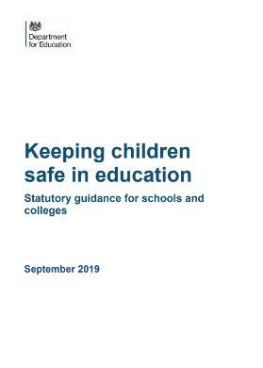

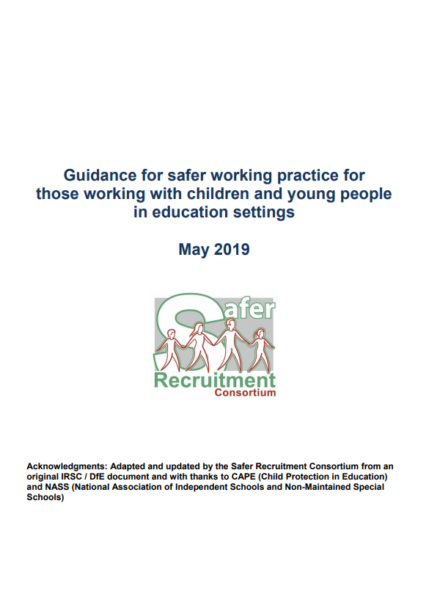

December 2019

# Our Safeguarding Commitment:

### There are four strands to our safeguarding commitment:

1. the establishing and maintenance of a secure ethos where children are able to talk and be listened to
2. ensuring that children know that there are adults in the school who they can approach if they are worried or are in difficulty
3. including in the curriculum activities and opportunities to learn about being healthy and staying safe, equipping children with the skills they need to stay safe from harm and from abuse
4. ensuring that every effort is made to establish effective working relationships with parents and with other agencies.

Our expectation is that all staff have read and understood Keeping Children Safe in Education part 1 and Guidance for Safer working practice in schools and educational settings [May 2019](http://www.saferrecruitmentconsortium.org/GSWP%20Sept%202019.pdf) (our staff code of conduct). Governors and Trustees need to be aware of both these documents in particular Keeping Children safe in Education [part 1 and part 2](https://www.gov.uk/government/publications/keeping-children-safe-in-education--2).

#### **Our Designated Safeguarding Leads (DSLs)**

|  |  |
| --- | --- |
| Lunesdale Learning Trust DSL: Lisa Longley | |
| QES | **QEStudio** |
| Lisa Longley | Alison Wilkinson |
| Alison Hooper | Cathy Harrison |
| Cathy O’Neill | Nathan Davies |
| Hayley Gray |  |
| Pete Weston |  |
| Trust Safeguarding Governor/Trustee: Jacqui Scott/Stewart Lawrenson | |

#### 

#### **Threshold Guidance and Early Help**

Threshold guidance refers to the criteria and threshold for social care intervention. We work with three counties dependent upon where the pupil resides. Each county has its own threshold guidance and gateway into social care.

Cumbria’s Threshold Guidance Model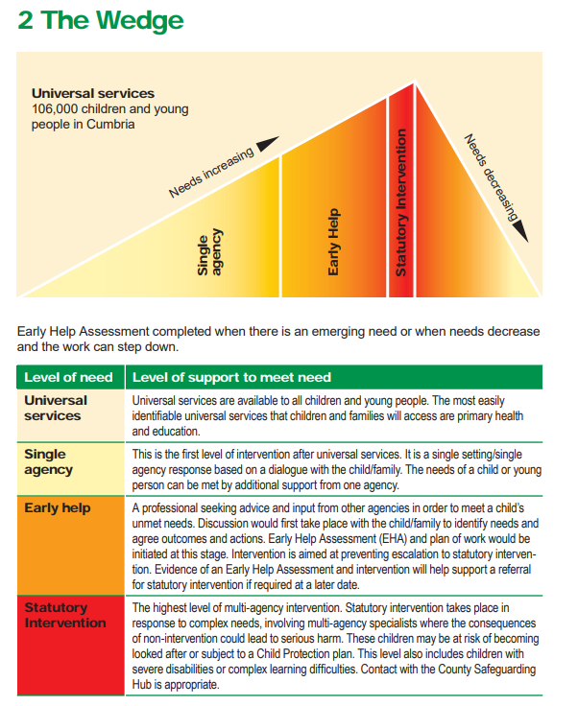

Early Help works on the principle that all Children require ‘Universal Support’ which includes access to health, dentists, education and from time to time some children and their families will be in need of some additional support. This is where Early Help comes in. Early Help is often ran by school. Parents, school and any other agency working with the child or family will contribute to an assessment called a CAF (Common Assessment Framework) for which key actions can be formulated to support the child and family.

Any child may benefit from Early Help, but it is more likely that we will initiate one if the child or young person:

* is disabled and has specific additional needs;
* has special educational needs;
* is a young carer;
* is showing signs of being drawn in to anti-social or criminal behaviour, including gang involvement and association with organised crime groups;
* is frequently missing/goes missing from care or from home;
* is at risk of modern slavery, trafficking or exploitation;
* is at risk of being radicalised or exploited;
* is in a family circumstance presenting challenges for the child, such as drug and alcohol misuse, adult mental health issues and domestic abuse;
* is misusing drugs or alcohol themselves;
* has returned home to their family from care;
* is a privately fostered child.

## *Peer on Peer abuse*

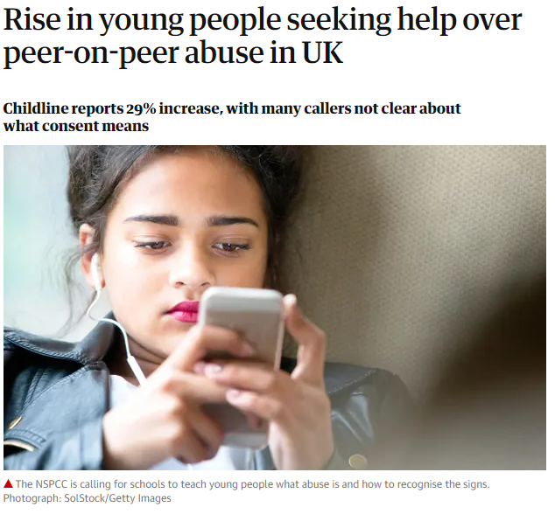

What is it?

It is the acknowledgement that children can abuse other children; we treat such events as a safeguarding matter.

It is most likely to include, but may not be limited to:

* bullying (including cyberbullying);
* physical abuse such as hitting, kicking, shaking, biting, hair pulling, or otherwise causing physical harm;
* sexual violence, such as rape, assault by penetration and sexual assault;
* sexual harassment, such as sexual comments, remarks, jokes and online sexual harassment, which may be stand-alone or part of a broader pattern of abuse;
* upskirting, which typically involves taking a picture under a person’s clothing without them knowing, with the intention of viewing their genitals or buttocks to obtain sexual gratification, or cause the victim humiliation, distress or alarm;
* initiation/hazing type violence and rituals.

Decisions about what to do should a case of peer on peer abuse become evident will be made on a case-by-case basis, taking into consideration:

* the wishes of the victim;
* the nature of the incident – might a crime have been committed?
* the ages of the children involved;
* any power imbalance between the children for example, if one child is much older
* whether it was a one-off incident or a pattern of behaviour by the alleged perpetrator